**Test Setup (07/12/24) bugs:**

1. Basic settings-mock test and main test text and radio button alignment is not same.
2. Basic settings-mandatory border is not changed to default after click clear button.

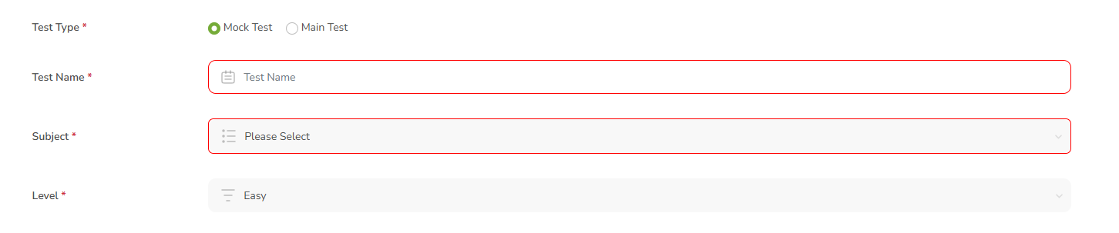

1. Basic setting-after mouse hover to the tabs, tool tip text is not displayed. Need to check in all tabs.
2. Time setup-For main test, enter less than 24 hours date and time in test setup and click save button, pop up display wrong details. Need to change-Close button is near to 24 so it displayed like 24 x hours and need space btwn date time and add “&” symbol between them.
3. Time setup-For main test, need to remove underline and it looks like link text.

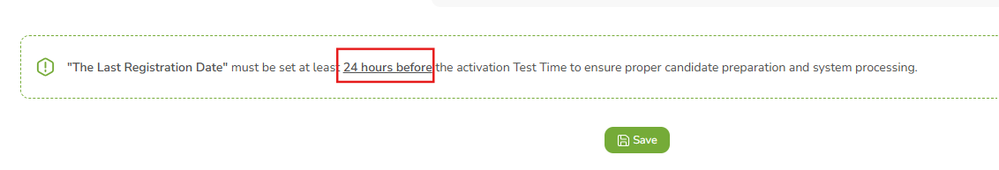

1. Time setup-For main test, after enter past time, error pop up should display like “Please enter valid date & time!” or any other valid message.

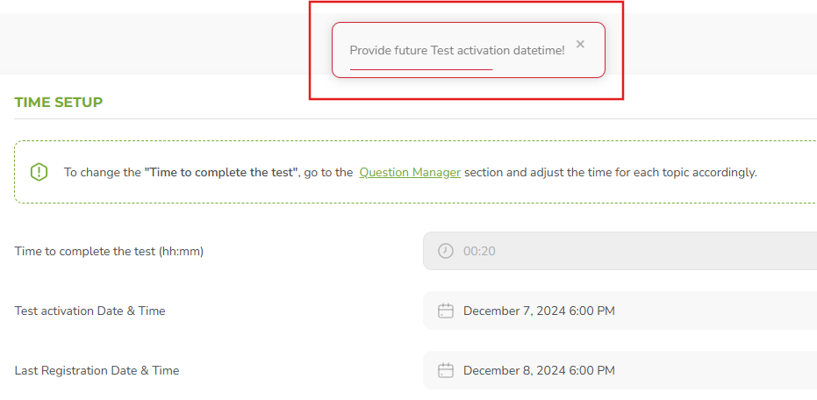

1. Grading Setup-After enter same from and to value is same, page gets accepted without any issues.

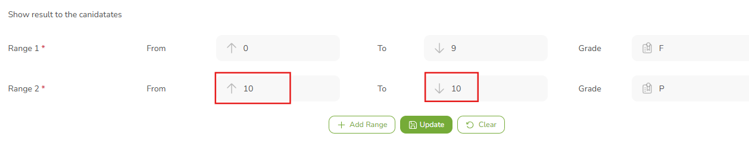

1. Certificate Template-Points, percentage and grade tabs are overlap with each other, it need minimum space.

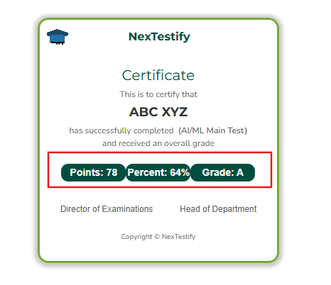

1. Time Setup-When provide last registration date & time was past time page gets accepted. But it should not accept those timing.

* **Suggestion**: Last registration date should not present date and it should more than 24hrs of current date and time.

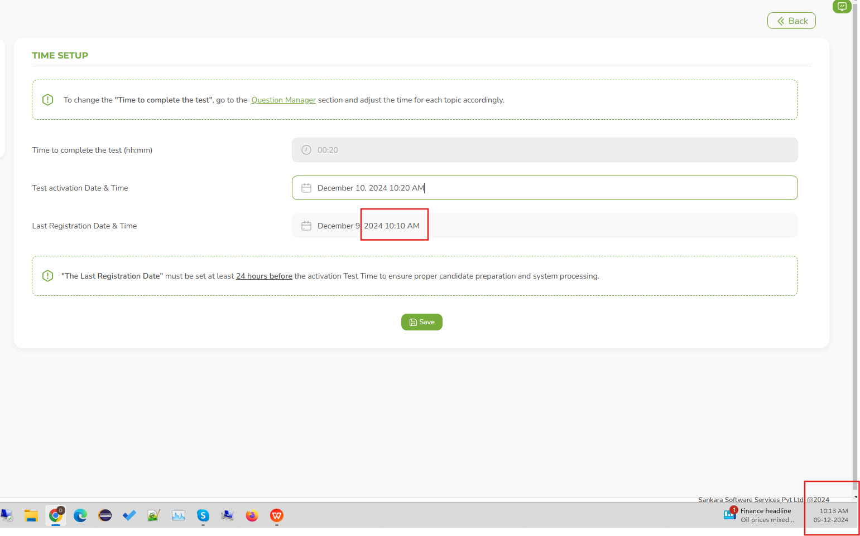

1. In **Question Manager**, overall points gave “10” and in **grading setup**, gave the pass mark value is more than “10” and range value is also gave more than “10”, not valid alert message is displayed.
2. In **Question Manager**, after enter valid details and click save button, tab moves to time setup and user can again click question manager, “Save” button is displayed and it need to display as “Update” button.
3. In Test Setup, after enter valid details in all tab and sucessfully saved the test, but in home page shows “Unscheduled” but it need to show the timing.
4. In Grading Setup, when enter the unit with percentage, page doesnot accept.
5. For mock test, after edit a mock test and click update button in time setup, certificate template and test access tabs are displayed.

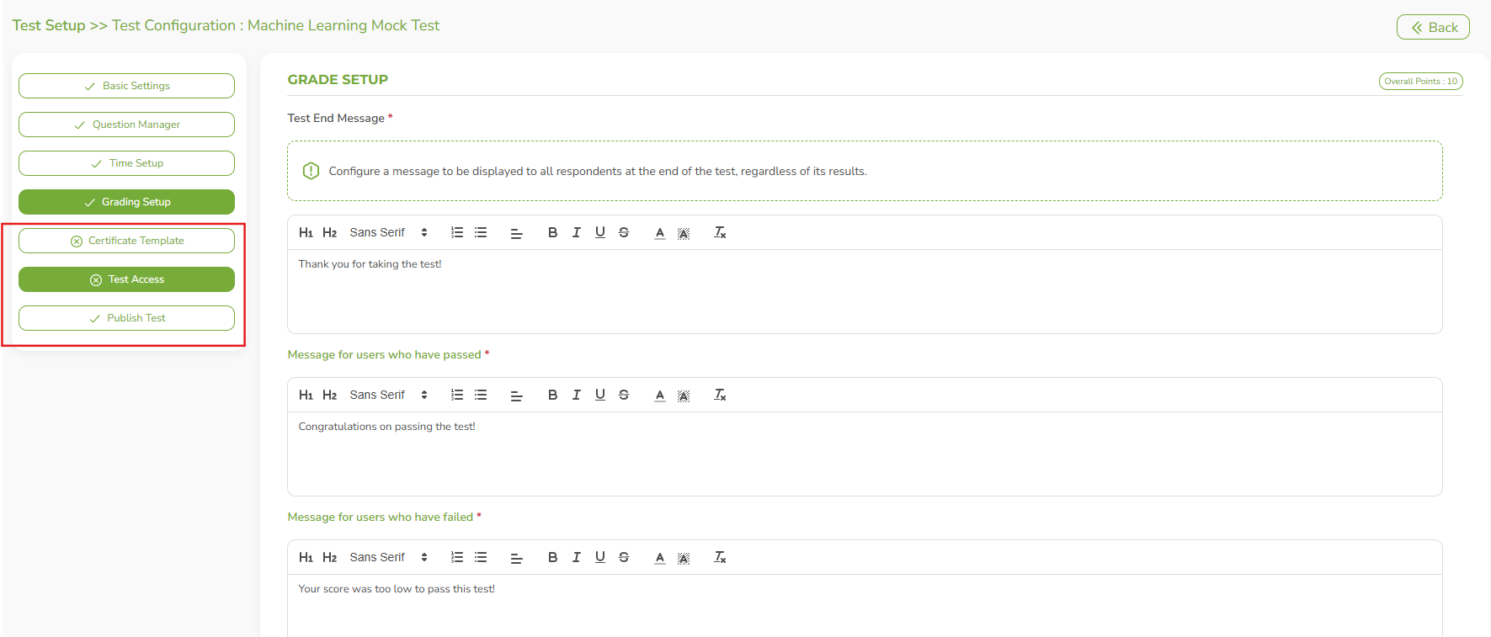

1. In Publish test, user name displayed with underline and need to remove that, it looks like link text.

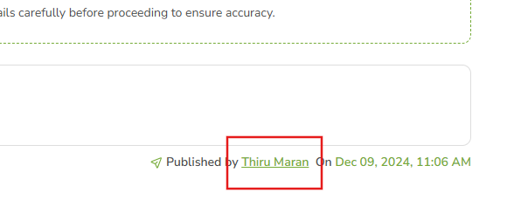

1. **Suggestion:** After last reg date and time is completed, user can able to modify the date and time. Need to discuss.